Support Vector Machines – Lesson 2

Playing around with changing gamma with the bumpy/grade set of data.

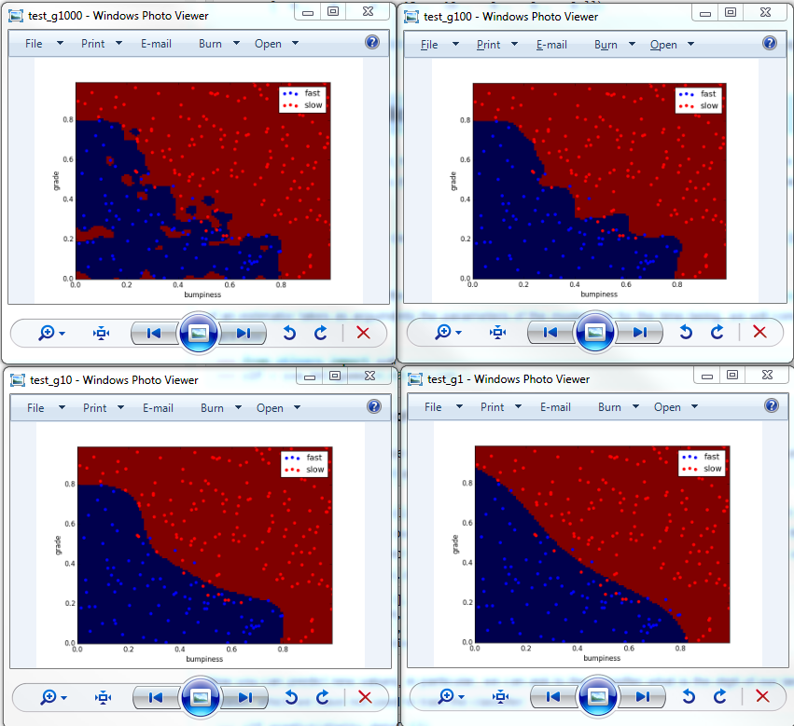
Above we see the change in the boundary line between the bumpiness and grade. Gamma ranges from 1000 to 10. We can see that as gamma increases, the complexity of the boundary increases significantly. For this set, my inexperienced eye would go with either gamma of one or ten (bottom two images.)

Took a bit to figure out how to set the gamma and C for the SVM. The code snippet is below:

from sklearn import svm

clf = svm.SVC(gamma=1, C=100);
clf.fit(features_train, labels_train);
predlabels = clf.predict(features_test)

The complete code is found in studentMainSVM.py

Effect of C on the boundary
The following block shows how the boundary changes as C is changed from 1 – 1000. Gamma is held steady at 1:

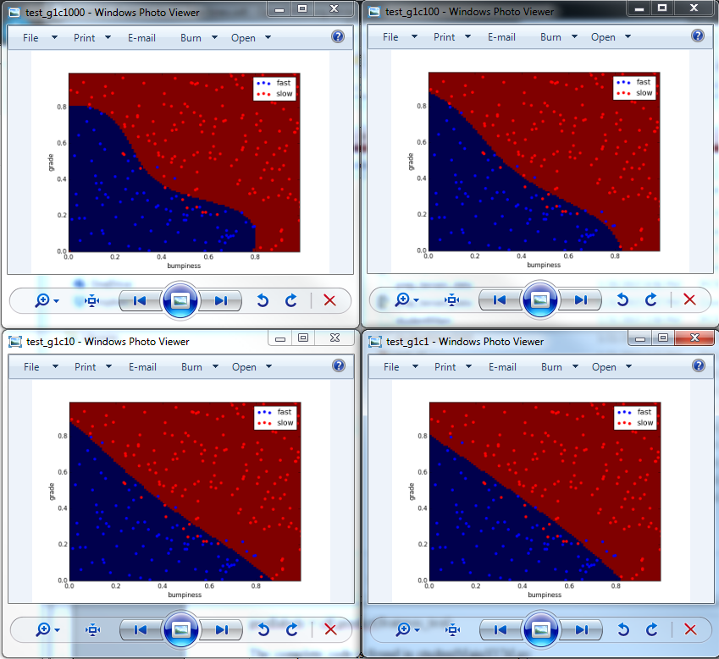
C changes the shape of the decision boundary, but it doesn't ever create blobs of one set inside of another (a high gamma value will do this).

Considerations in Machine Learning

- Over fitting: too high of a gamma or C or the kernel selected can cause over training. This is observable when a very complicated boundary is created. We want to capture as much of a set as possible, without over training the boundary.

Boundary or decision surface

Support Vector Machine Summary
- Doesn't work well with huge data sets (prone to over training)
- Doesn't work well with really noisy data. Naïve Bayes works much better when there is a lot of noise in the data.
- SVM not good if there is a huge data set and lots of features. If this is the case SVMs will be slow and prone to over fitting. (What is considered to be 'lots of features' or a 'huge data set'?) Time complexity for training is O(m^3) and space complexity is O(m^2) where m is the training set size. (If I don't want to use more than 1GB of ram for space then I'm limited to a data set of size 32,768.

Mini Project with SVM
- How is training time and prediction time affected by our selection of gamma, C, and other parameters?
- In the data set there are 7936 training emails for Chris and 7884 training emails for Sara. The SVM was initialized with C=1 and gamma=a with a linear type kernel.
  - Training time: 359 sec ~ 6 min
  - Prediction time: 37.7 sec
  - Accuracy: 98.4%
  - Observations: That took a long time! Accuracy was great, but dang.
- In chopping the features and labels training set size down to 1% of the original we get the following stats:
  - Training time: 0.196 sec
  - Prediction time: 2.012 sec
  - Accuracy: 88.5%
  - Observations: Wow, much faster. But the tradeoff was accuracy.
- The specifications for training and prediction speeds versus accuracy will be dictated by the constraints of the application we're working with (siri voice recognition vs. predicting author of an email, one obviously has real time constraints where the other doesn't).
- For run with 1% of data, kernel = 'rbf'
  - Training time: 0.23 sec
  - Prediction time: 2.49sec
  - Accuracy: 61.6%
  - Observations: Hmm, more complex kernel, but the results are much worse and no savings in computation time. Complex doesn't equate to better.
- For run with 1% data, kernel = 'rbf',

C Value | 10 | 100 | 1000 | 10000
Training Time | 0.21 sec | 0.21 | 0.2 | 0.2
Prediction Time | 2.618 sec | 2.32 | 2.26 | 1.85
Accuracy | 61.6 | 61.6 | 82.1 | 89.2

- Observations: It's interesting that the prediction time decreases while the accuracy improves. That's counterintuitive to me.
- With C optimized I'm going back to the whole training set. Supposedly things should work more quickly now with C optimized... but we'll see.
  - Training time: 216.87 sec (~3.6 min)
  - Prediction time: 22.6 sec
  - Accuracy: 99.0%
  - Observations:

- Prediction of elements 10, 26, and 50 of the training set
  - 10: [1]
  - 26: [0]
  - 50: [1]

